**LAB WORK**

**EXAMPLES**

**(A)**

## To display record of employees who are not managers

SELECT * FROM EMP WHERE JOB <> ‘MANAGER’;

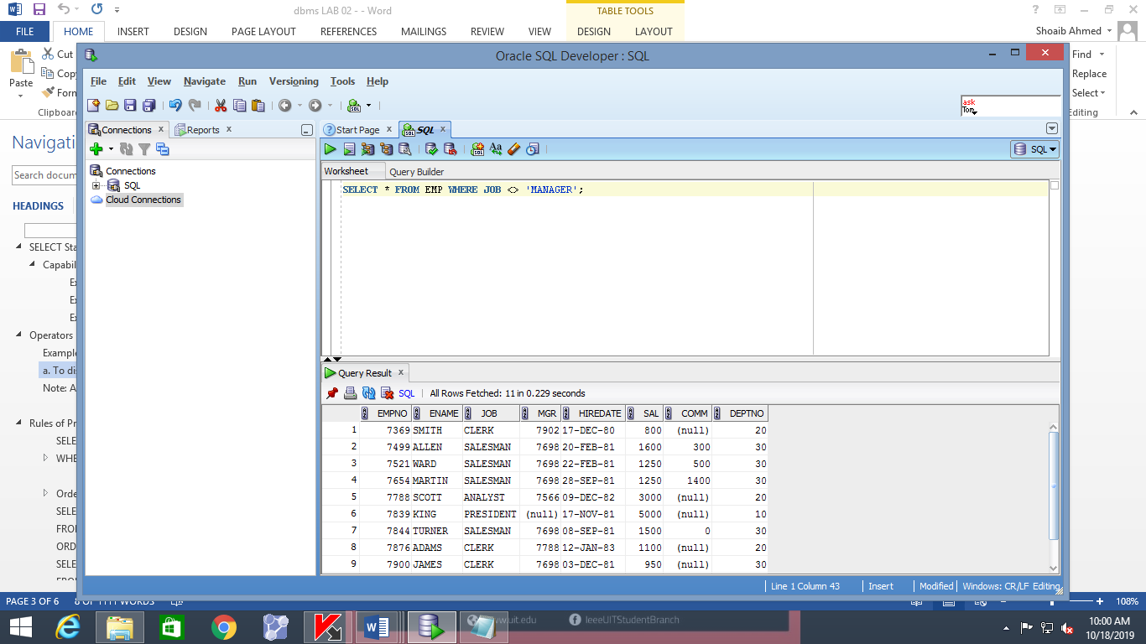

SELECT * FROM EMP WHERE JOB NOT IN (‘MANAGER’);

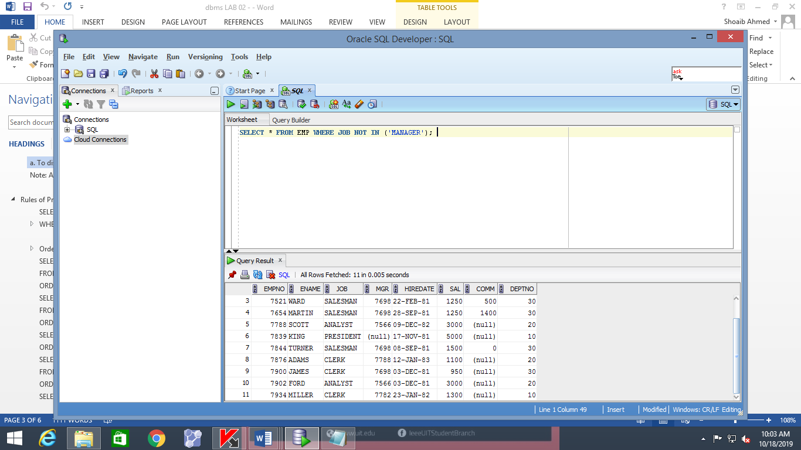

SELECT * FROM EMP WHERE JOB NOT IN (‘MANAGER’,’CLERK’);

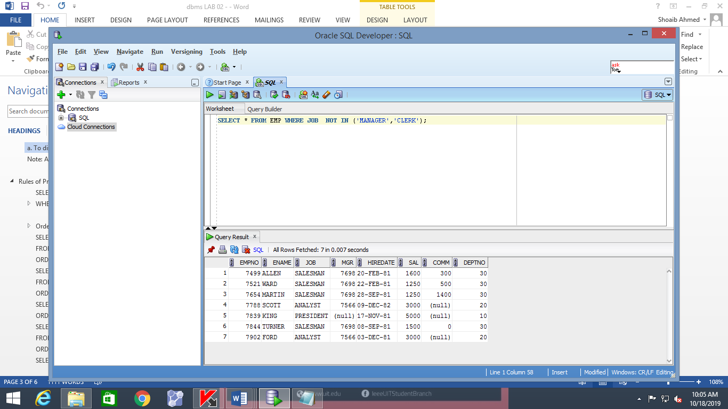

SELECT * FROM EMP WHERE JOB IN (‘MANAGER’,’CLERK’);

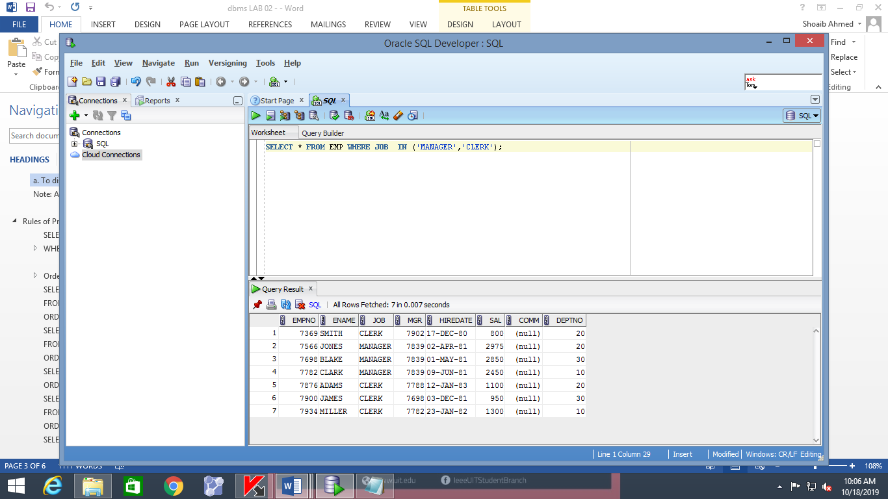

**(B)**

SELECT EMPNO, ENAME, SAL, MGR FROM EMP WHERE MGR IN (7902, 7566, 7788);

To display the employee number, name, salary and the manager’s employee number of all the employees whose manager’s employee number is 7902, 7566, or 7788.

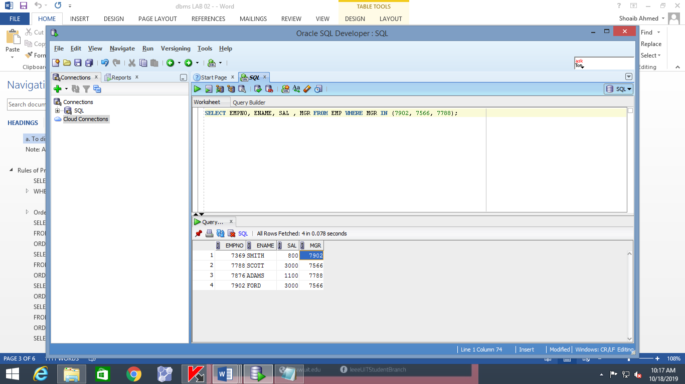

SELECT EMPNO, ENAME, SAL, MGR FROM EMP WHERE MGR = ‘7902’ OR MGR = ‘7566’ OR MGR = ‘7566’;

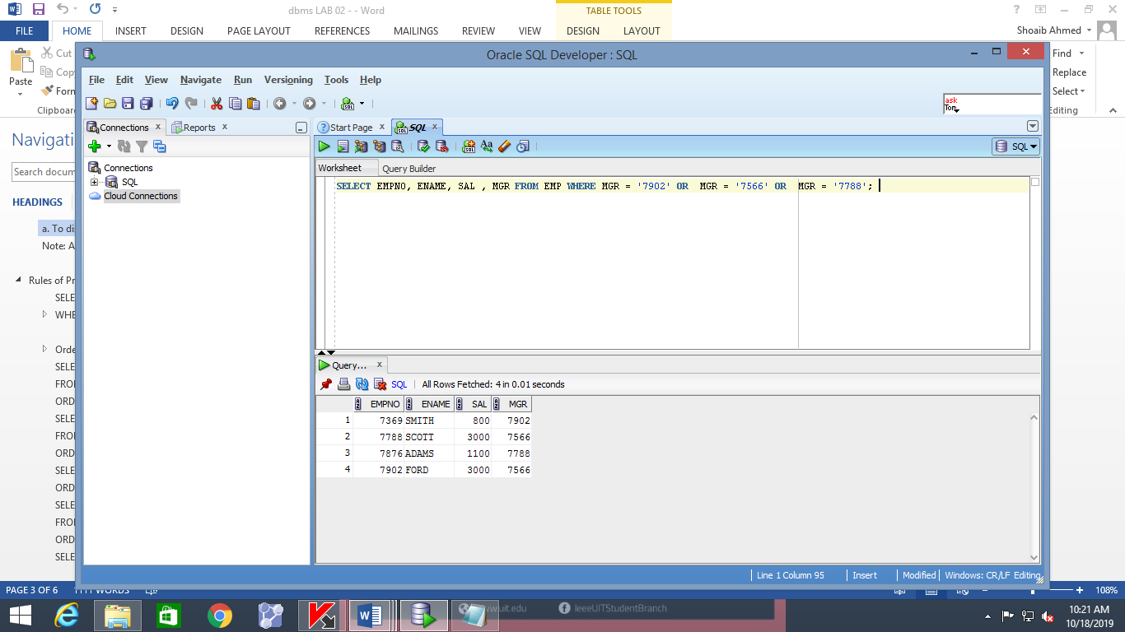

**C**

SELECT ENAME FROM EMP WHERE ENAME LIKE ‘S%’;

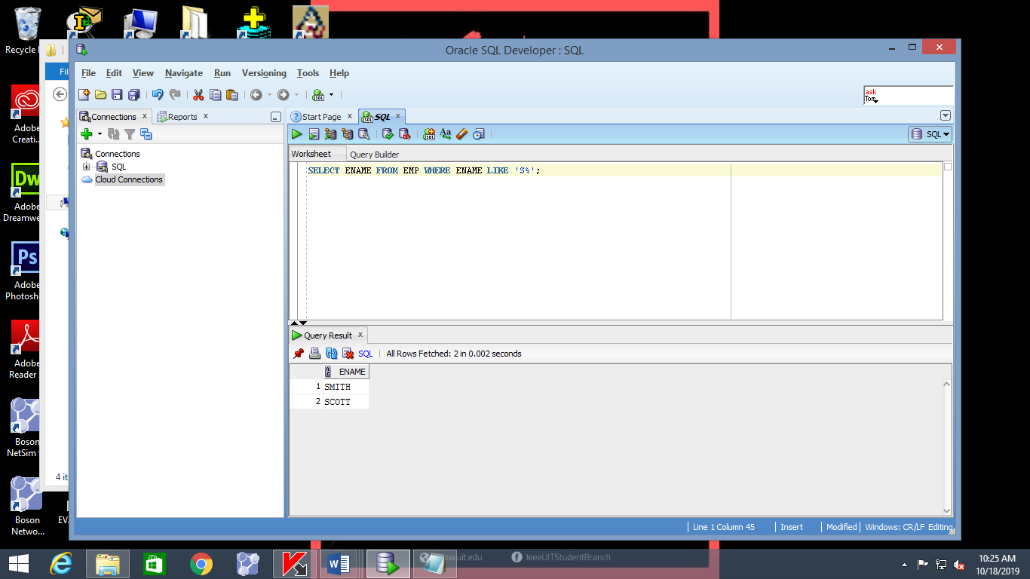

SELECT ENAME FROM EMP WHERE ENAME LIKE ‘CL%’;

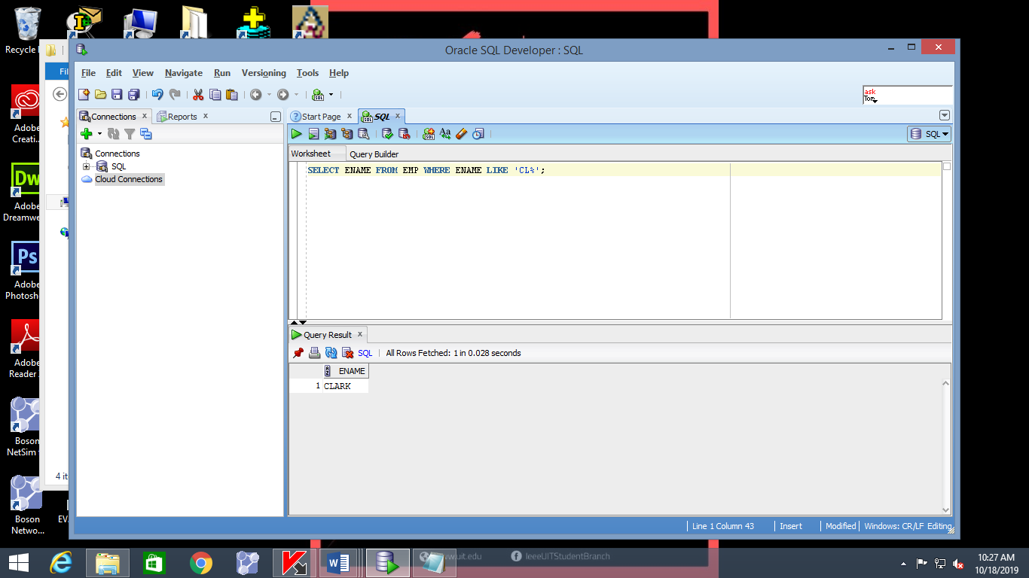

SELECT ENAME FROM EMP WHERE ENAME LIKE ‘%S%’;

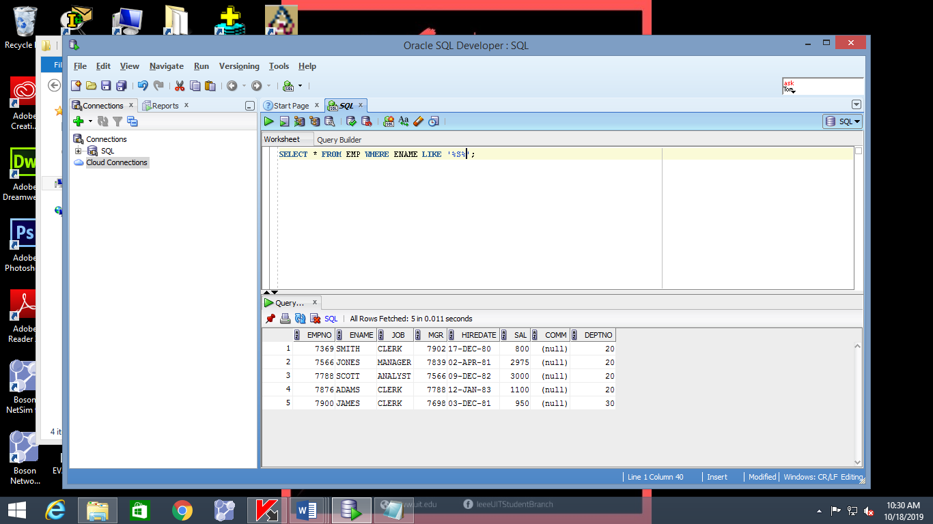

**(D)**

To display the names of all employees with second character of name as **A,**

SELECT ENAME FROM EMP WHERE ENAME LIKE ‘_A%’;

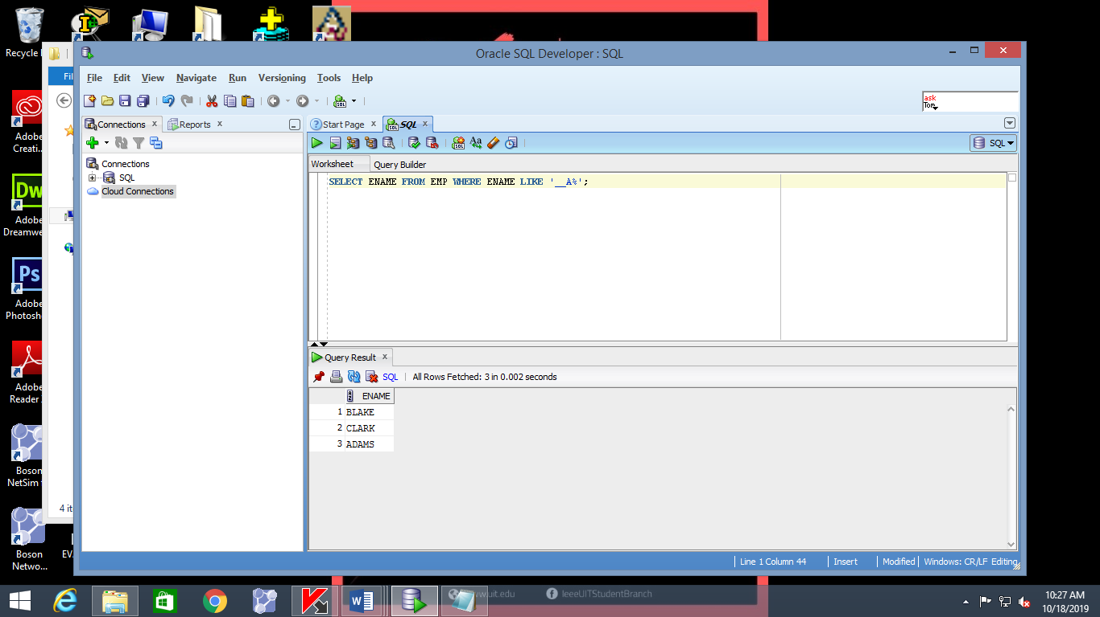

SELECT ENAME FROM EMP WHERE ENAME LIKE ‘A%_A%’;

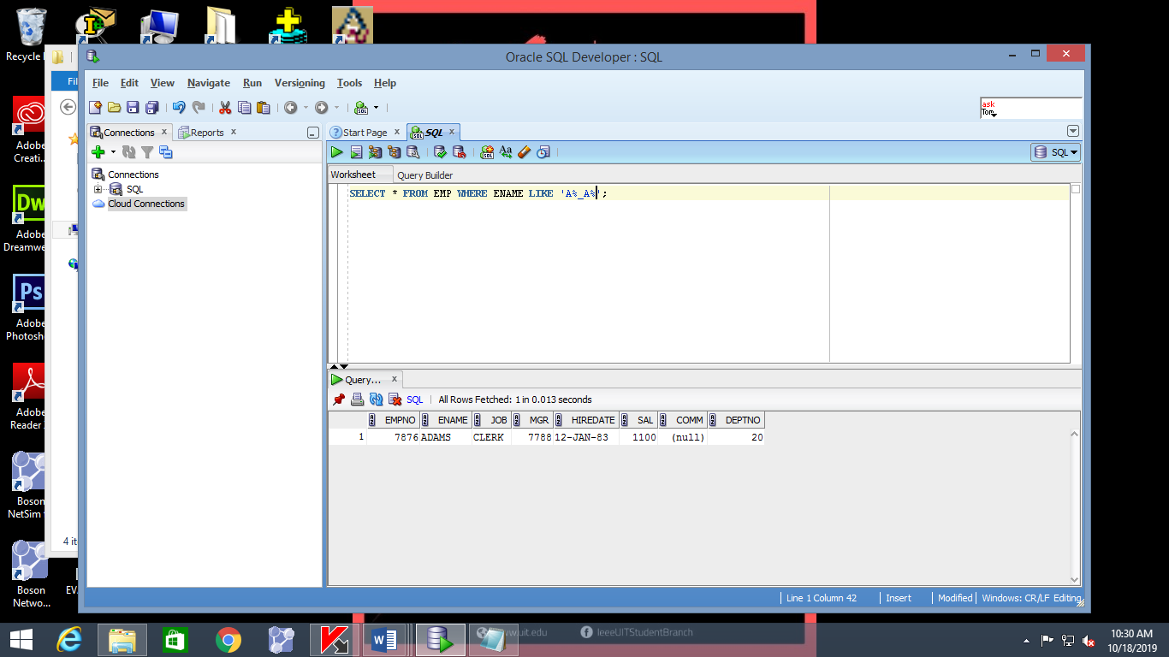

SELECT ENAME FROM EMP WHERE ENAME LIKE ‘_LA%’;

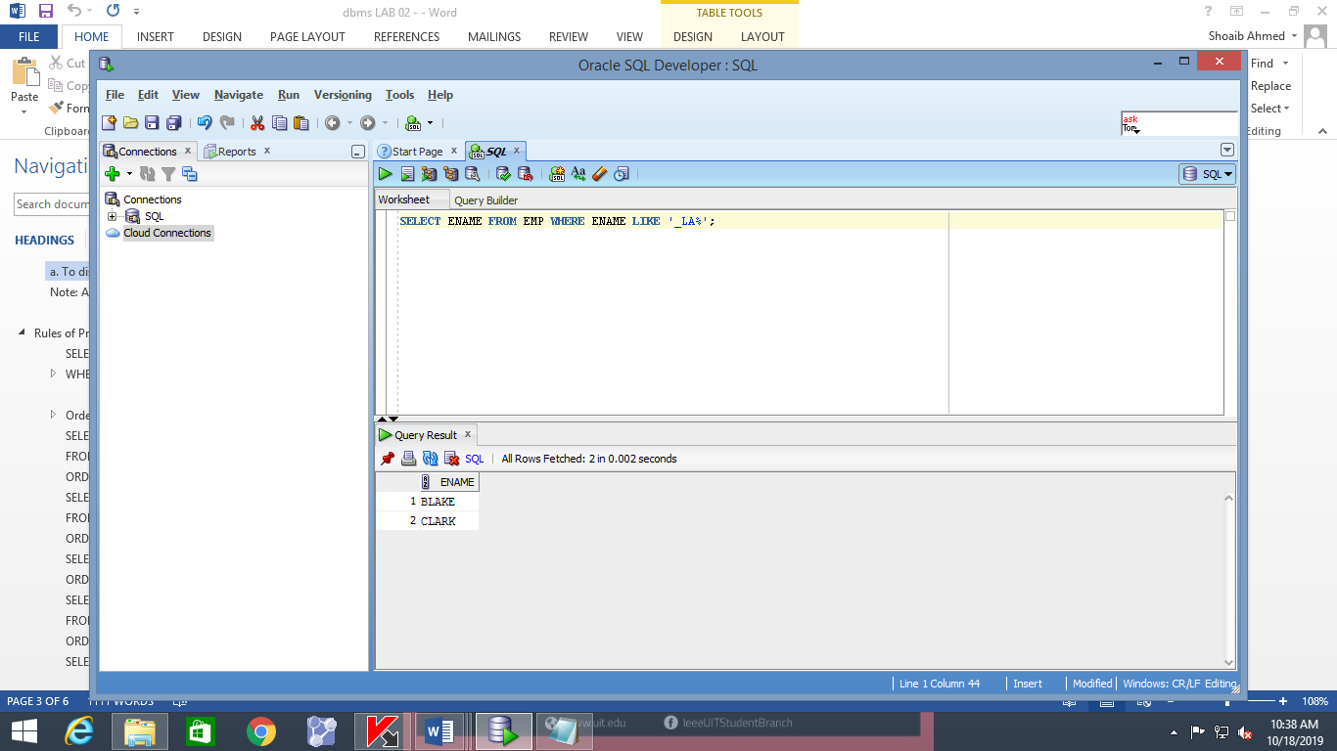

**(E)**

To display record of all clerks who earn more than 1100

SELECT empno, ename, job, sal

FROM emp

WHERE sal >= 1100

AND job = ‘CLERK’

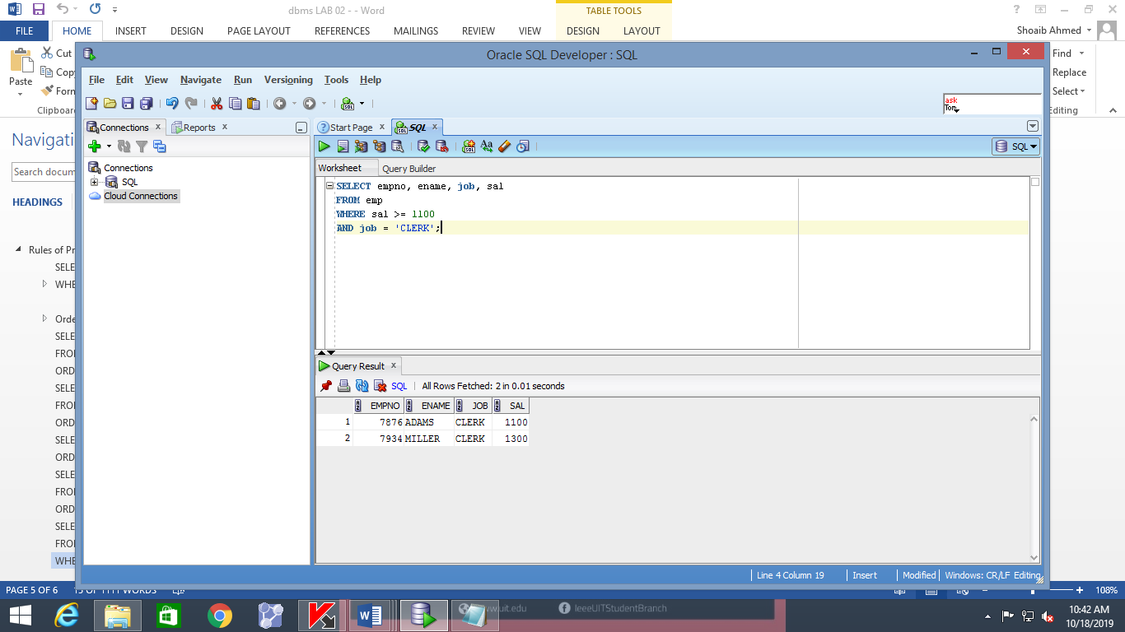

**(F)**

To display record of all employees who are either clerks or earn more than 1100.

SELECT empno, ename, job, sal

FROM emp

WHERE sal >= 1100

OR job = ‘CLERK’;

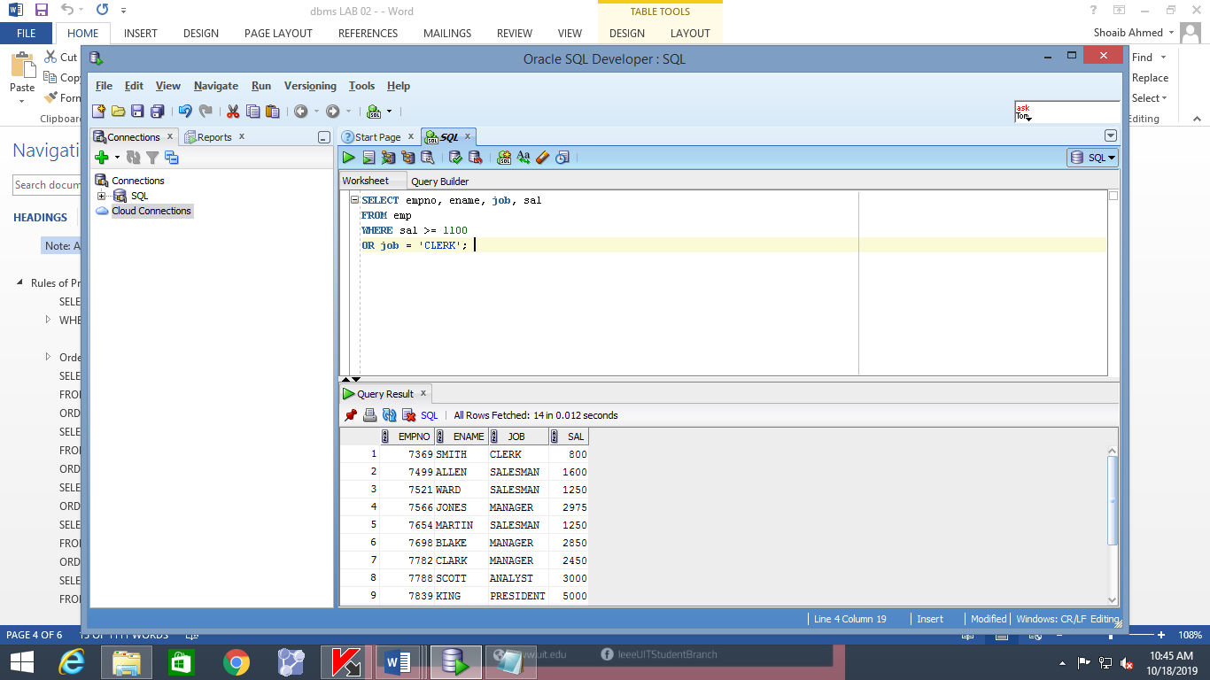

**(G)**

To display name and job title of all the employees whose are not CLERK, MANAGER, or ANALYST.

SELECT ename, job

FROM emp

WHERE job NOT IN (‘CLERK’, ‘MANAGER’, ‘ANALYST’);

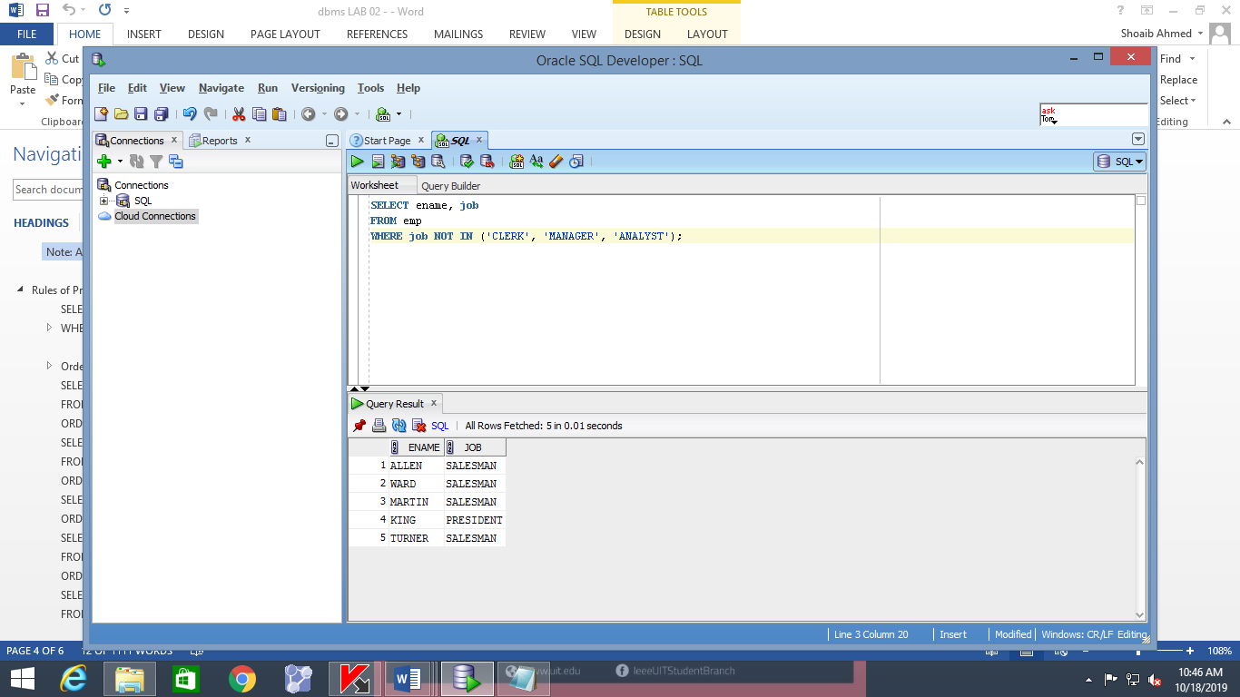

**ORDER BY**

To select data in the increasing order of hiredate

### SELECT ENAME, JOB, DEPTNO, HIREDATE

### FROM EMP

### ORDER BY HIREDATE;

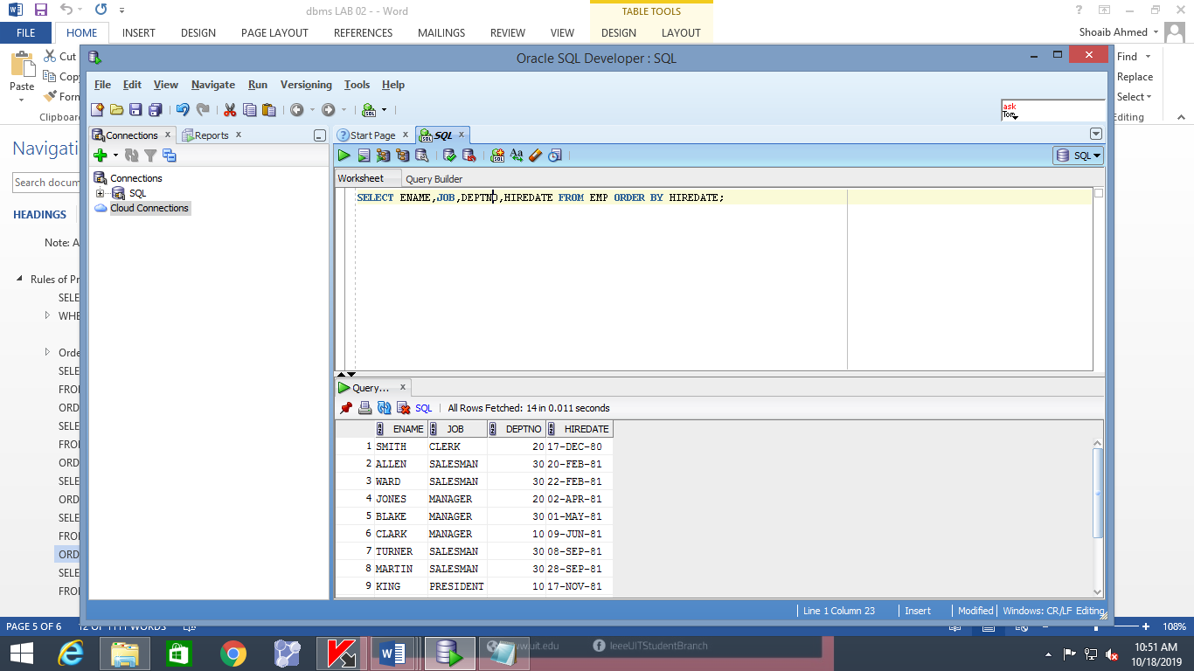

To select data in the decreasing order of hiredate,

### SELECT ENAME, JOB, DEPTNO, HIREDATE

### FROM EMP

### ORDER BY HIREDATE DESC;

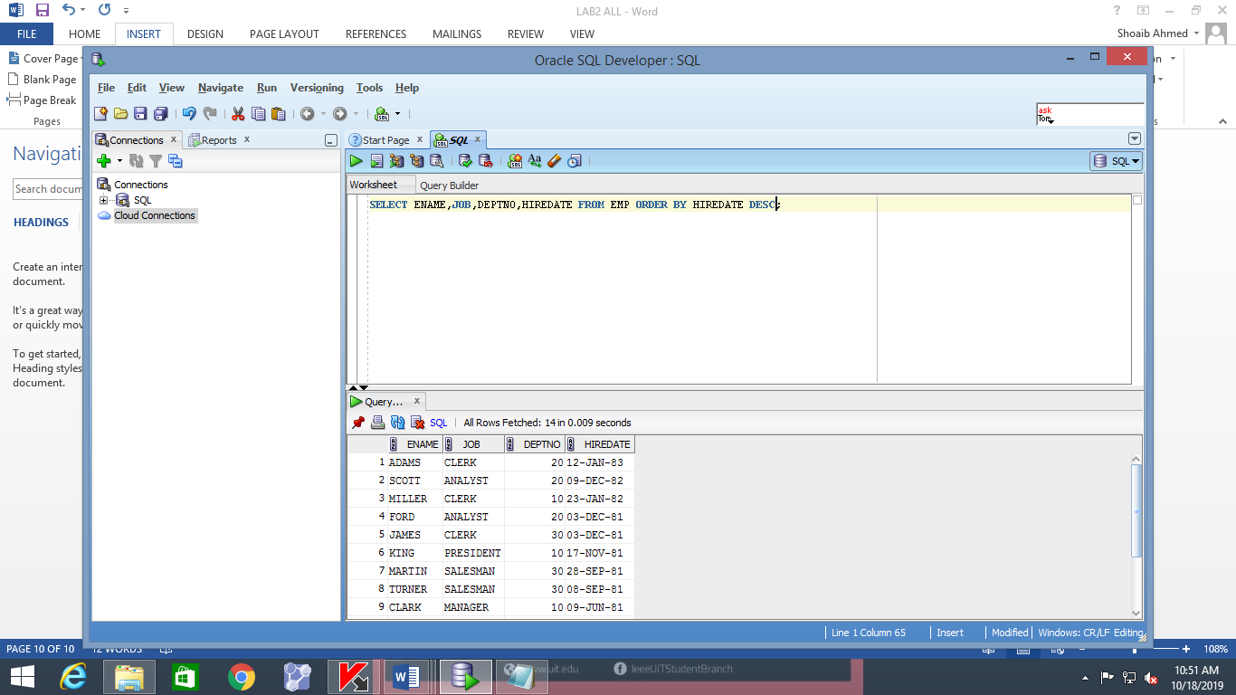

### SELECT ENAME, JOB, DEPTNO, HIREDATE

### FROM EMP

### ORDER BY HIREDATE ASC;

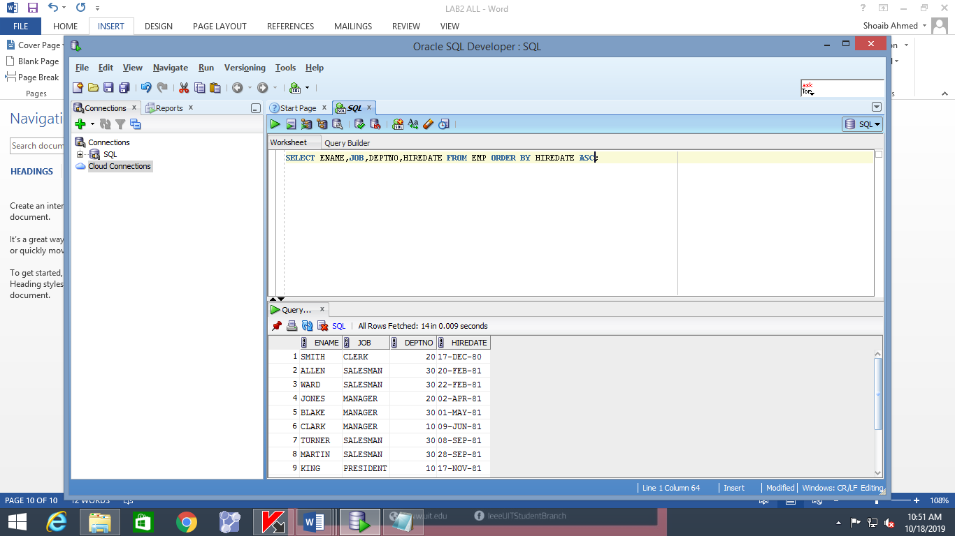

**Student Excises**

1. **To display the name and department number of employee with number 7566.**

**SELECT ENAME, DEPTNO FROM EMP WHERE EMPNO IN(7566);**

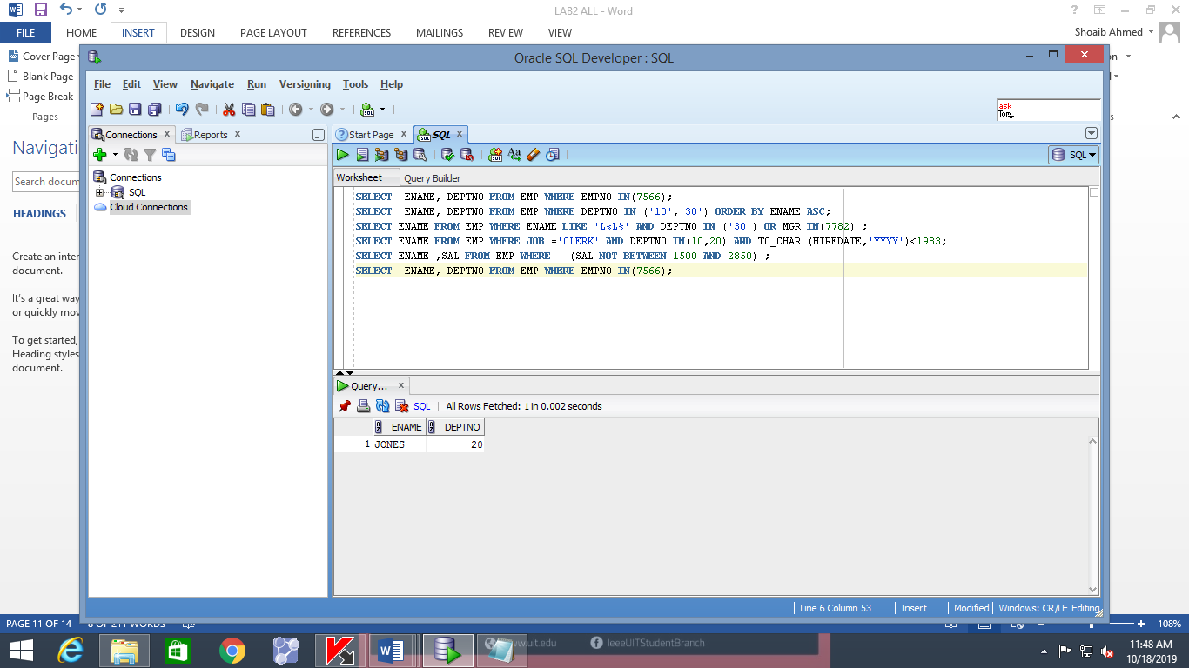

1. **To display the name and department number of all employees in departments 10 and 30 in alphabetical order by name.**

**SELECT ENAME, DEPTNO FROM EMP WHERE DEPTNO IN ('10','30') ORDER BY ENAME ASC;**

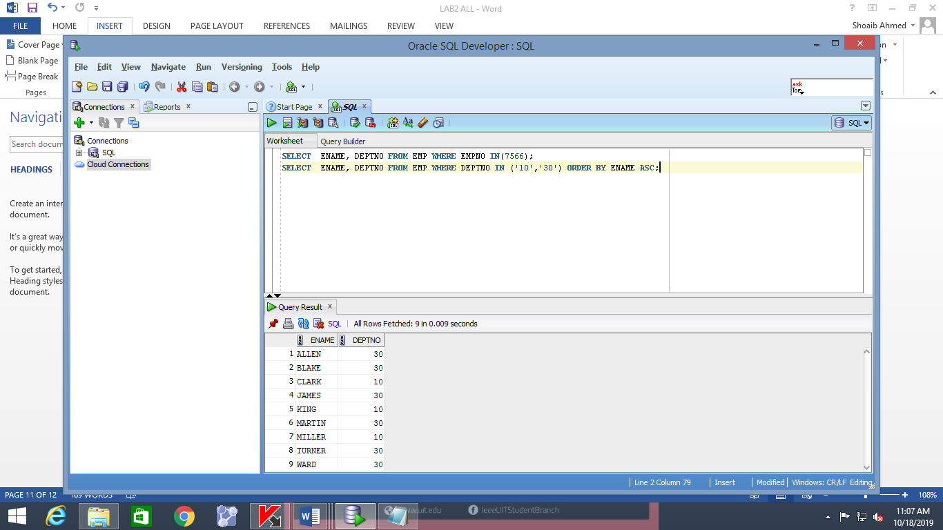

1. **To display the name, department number and hire date of all employees who were hired in *1982*.**

**SELECT ENAME DEPTNO,HIREDATE FROM EMP WHERE TO_CHAR (HIREDATE,'YYYY')=1982;**

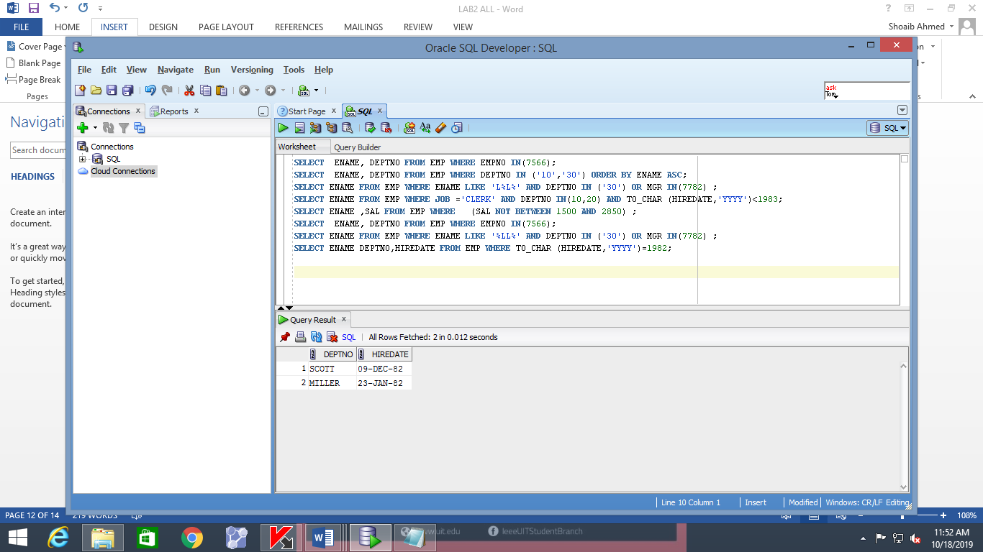

1. **To display the name of all employees who have two consecutive Ls in their name and are in department 30 or their manager is 7782**

**SELECT ENAME FROM EMP WHERE ENAME LIKE '%LL%' AND DEPTNO IN ('30') OR MGR IN(7782) ;**

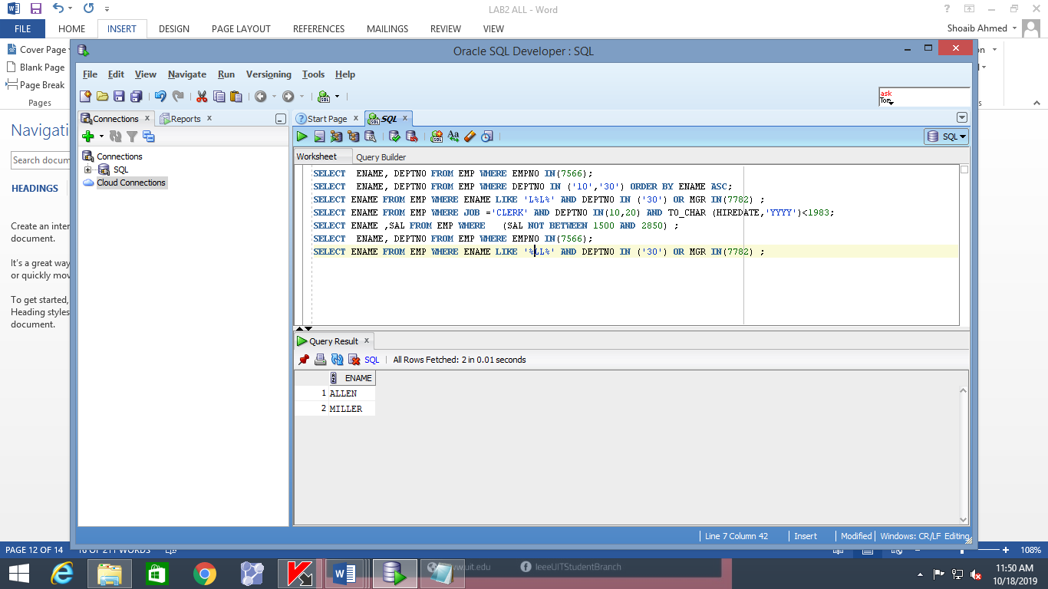

1. **To display the name of all clerks of department 10 and 20 hired before 1983**

**SELECT ENAME FROM EMP WHERE JOB ='CLERK' AND DEPTNO IN(10,20) AND TO_CHAR (HIREDATE,'YYYY')<1983;**

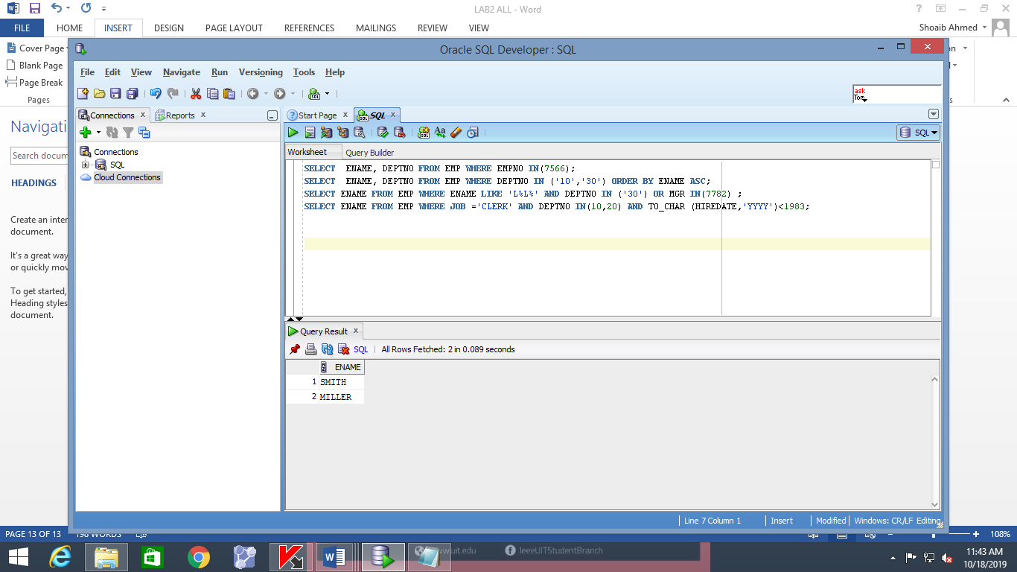

1. **Display the name and salary for all employees whose salary is not in range of $1500 and $2850.**

**SELECT ENAME, SAL FROM EMP WHERE (SAL NOT BETWEEN 1500 AND 2850);**

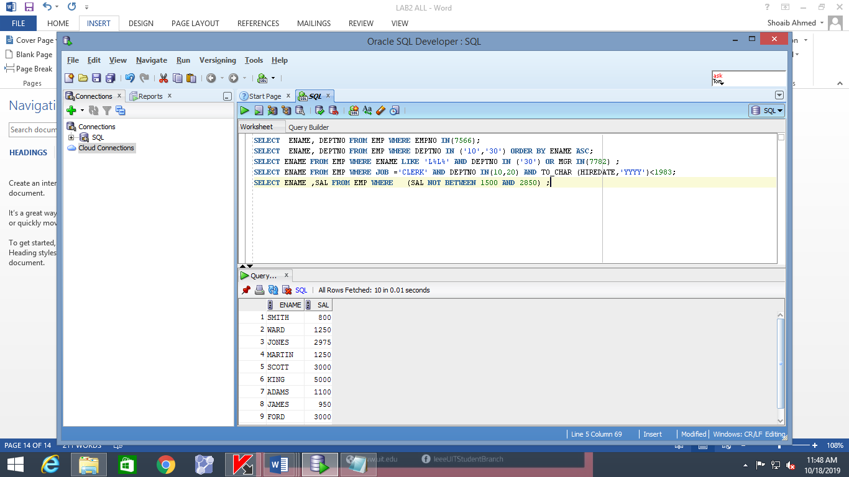

1. **Display the name, salary and commission for all employees whose commission amount in greater than their salary increased by 10%.**

**SELECT ENAME ,SAL+SAL*0.1,COMM FROM EMP WHERE COMM>SAL;**

